Instructions and guidelines:

1. This is a team-based task. You need to work with your team members to complete this task.
2. Use the given template, in MS-Word format, to complete the requirements of this task.
3. Upload your completed document file, in PDF format, on Moodle.
4. One submission is needed by each team.

|  |  |
| --- | --- |
| **Course Learning Outcomes (CLO)** | |
| CLO1 | Define an application to design and implement. |
| CLO2 | Prepare a project proposal, which includes project statement, project’s objectives, a high-level plan for the project, including main phases, budget, and timeline. |

Task 2 – Software Requirements Specification

Use the following template to prepare your project requirements specification document.

|  |  |
| --- | --- |
| **Task:** | **Software Requirements Specification** |
| **Project Title:** | **Intelligent Autonomous Hoover as an IoT Solution** |
| **Team Members’ Names:** | 1. Nawaf Alzahem 2. Fahad Aldulaigan 3. Mohammad Abuhaimed 4. Khalid Abu Alsaud 5. Khalid Hali |
| **Supervisor Name:** | **Dr. George Violettas** |
| **Date:** | **20/10/2022** |

# Proposed System:

* 1. **: Overview**

The system being considered to be developed is the AI powered Robotic Vacuum cleaners referred as the hoovers which are the autonomous devices which are being used worldwide. The new system being developed would be the automated robotic hoover which would be significantly effective and easy in using. The AI powered Robotic vacuum cleaners would include the functionalities of biometrical recognition features which would allow facial or even voice recognition abilities.

* 1. **: Functional Requirements**

There are 3 main users or actors of the new hoover using AI which are students, admin, staff and (faculty) is **optional**. The functional requirements of the system are:

* System should allow the admin of the college to input the locations to be cleaned around the complete campus.
* System should allow the admin to use facial recognition for checking the database of services provided around the campus.
* System should allow the admin to use voice recognition for providing cleaning instructions to the hoover which would travel the complete campus.
* System should allow the students to input cleaning requests in the hoover.
* System should allow the staff of the college to check the cleaning requests and then approve the cleaning tasks.
* System should allow the admin to input new biometric data of the users by entering the complete biometric features in the hoover.
* System should allow the admin to edit the details of any users for ensuring that all biometric features would be accepted.
  1. **: Non-Functional Requirements**

### User interface

The user interface being added for the hoover should include simple elements and features which could easily be used by vast range of users. The system should allow alternate languages for ensuring all types of users would be able to access the features easily.

### Documentation

The system should have the ability of documenting and logging all the activities being requested from the hoover which would be helpful for future analytics and gain insights. The analysis of the locations around the campus would be done for checking which locations need frequent cleaning and what could be done for improving the cleaning.

### Hardware consideration

The hardware being considered for the new hoover device is the webcam on the vacuum screen which could be used by the users for providing the instructions and make the hoover work easily.

### Performance characteristics

The system should take input within approximately 0.2 second from the touch screen and provide appropriate output as needed by the users. The system should provide throughput of taking multiple orders per second. Any incorrect details being entered into the hoover should be easily detected and then error message should be displayed along error resolution techniques.

### Error handling and extreme conditions

Any incorrect details being entered into the hoover should be easily detected and then error message should be displayed along error resolution techniques. The error resolution method should be not be altered for similar types of errors.

### System interface

The system would take input through voice recognition, facial recognition as well as user input through the webcam screen on the hoover. The system would also take input from the app connected with the hoover which would provide the users with improved method of providing the input.

### Quality issues

The interface of the hoover should be developed with proper materials for ensuring any kind of input would be accepted by the users. The voice recognition should match the voice of the pre-defined users and only take input from these users.

### System modifications

The system should allow modifications in the overall underlying interface of the hoover as well as the facial or voice recognition data being entered into the system. The system should provide the ability of providing additional input of the users who could be accessing the hoover through facial recognition.

### Physical environment

The hoover would work in any condition of the rooms around the college campus. The system would allow the users to make the hoover travel to any distance to ensure proper cleaning is being done for the entire campus.

### Security issues

The system handle any security issue containing the locations around the campus and the data of the users who are allowed to provide input into the system. The system should implement proper security protocols such as two factor authentication for accessing the database containing details of the users.

### Resource issues

The resources which would be used in the system should be made available at all times. Any determined issues should be handled properly through providing issue tackle method that would secure entire system.

# Constraints:

* + All the elements of project would need the access to proper stable internet connection. The hoover system would not be able to work without the constant access to wireless internet.
  + Any user with no understanding of the language with which the hoover is displaying instructions would not be able to use the hoover properly.

# System Model:

## Scenarios

* + User inputs the locations around the campus that has to be cleaned with the hoover.
  + User login into the application to check the database of the logs kept of the services being provided to the various locations in the campus.
  + Users input the cleaning requests in the hoover.
  + Users input new biometric data into the application of any new staff added in the college who would be controlling the hoover.
  1. **: Use Case Diagrams**

**3.3: State diagrams**

**3.4: Activity diagrams**

**3.5: Sequence diagram:**

**3.5: User interface:**

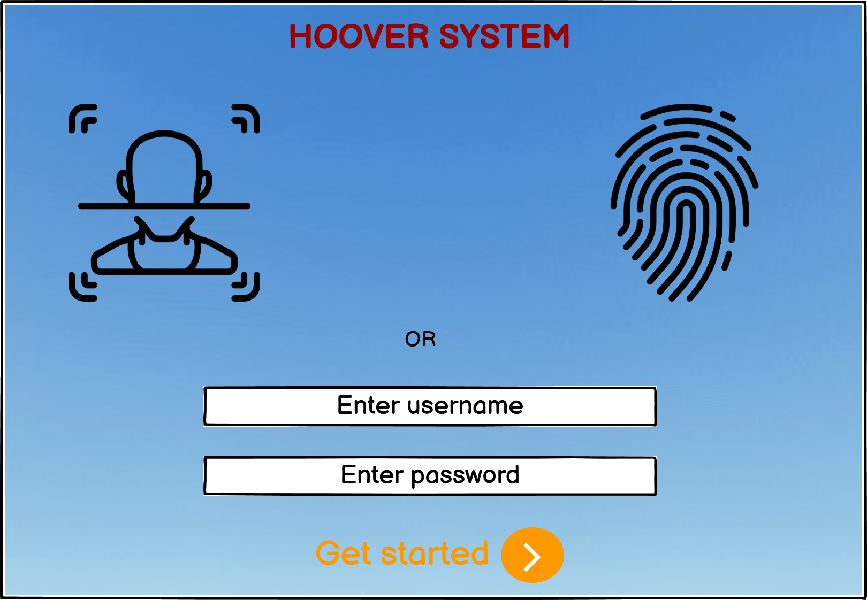

# References:

1. Asadabadi, M. R., Chang, E., Zwikael, O., Saberi, M., & Sharpe, K. (2020). Hidden fuzzy information: Requirement specification and measurement of project provider performance using the best worst method. *Fuzzy Sets and Systems*, *383*, 127-145.
2. Darnoto, B. R. P., & Siahaan, D. (2021, October). MultiPhiLDA for Detection Irrelevant Software Requirement Specification. In *2021 International Conference on Computer Science, Information Technology, and Electrical Engineering (ICOMITEE)* (pp. 92-97). IEEE.
3. Olaide, F. O., & Nyadru, I. (2018). Automated Personal Clinic Services in Uganda Software Requirement Specification.
4. Pamungkas, J. A., Priyadi, Y., & Alibasa, M. J. (2022, June). Measurement of Similarity Between Requirement Elicitation and Requirement Specification Using Text Pre-Processing in the Cinemaloka Application. In *2022 IEEE World AI IoT Congress (AIIoT)* (pp. 672-678). IEEE.
5. Raikar, S., & Cholli, N. G. (2021, December). An Analysis of Ambiguity Detection Techniques for Software Requirement Specification. In *2021 IEEE International Conference on Computation System and Information Technology for Sustainable Solutions (CSITSS)* (pp. 1-4). IEEE.
6. SABRIYE, A. O. J. A., & Zainon, W. M. N. W. (2018). AN APPROACH FOR DETECTING SYNTAX AND SYNTACTIC AMBIGUITY IN SOFTWARE REQUIREMENT SPECIFICATION. *journal of theoretical & applied information technology*, *96*(8).
7. Susilowati, M., Ahsan, M., & Kurniawan, Y. (2019, December). What does the software requirement specification for local E-Government of citizen database information system? An analysis using ISO/IEC/IEEE 29148–2011. In *Journal of Physics: Conference Series* (Vol. 1402, No. 2, p. 022087). IOP Publishing.
8. Vineetha, K. V., & Samuel, P. (2022, June). A Multinomial Naïve Bayes Classifier for identifying Actors and Use Cases from Software Requirement Specification documents. In *2022 2nd International Conference on Intelligent Technologies (CONIT)* (pp. 1-5). IEEE.